FCC RF TEST REPORT

|  |  |
| --- | --- |
| **Report No.:** | @inp_reportno |
| **Model No.:** | @inp_projectname |
| **Grant No.:** | @inp_grantno |
| **FCC ID:** | @inp_fccid |
| **Date of Receipt:** | @inp_dateofreceipt |
| **Date of Test:** | @inp_dateoftest |
| **Date of Issue:** | @inp_dateofissue |
| **Test Result:** | @inp_finaljudgement |

|  |  |
| --- | --- |
| **Applicant:** | @inp_brand CORPORATION |
| **Manufacturer:** | @inp_brand CORPORATION |
| **Factory:** | @inp_brand CORPORATION |
| **Product Name** | @inp_producttype |
| **Trade Mark** | @inp_brand |
| **Address:** | @inp_addressofbrand |
| **Issued By:** | BYD Precise Manufacture Co., Ltd. |
| **Lab Location:** | No. 3001, Baohe Road, Baolong  Longgang, Shenzhen, 518116, People’s Republic of China |

This test report consists of @inp_totalpages pages in total. It may be duplicated completely for legal use with the approval of the applicant. It should not be reproduced except in full, without the written approval of our laboratory. The client should not use it to claim product endorsement by A2LA or any government agencies. The test results in the report only apply to the tested sample.

Table of Contents

1 REPORT ISSUED HISTORY 4

2 CERTIFICATION 5

3 SUMMARY OF TEST RESULTS 6

3.1 Measurement Uncertainty 7

4 GENERAL INFORMATION 8

4.1 Test Equipments List 8

4.2 Description of Test Modes 9

4.3 Test Environment and List of Software and Accessory 9

4.4 Testing Location 10

4.5 Test Facility 11

4.6 Configuration of System Under Test 12

4.7 General Description of Applied Standards 13

5 TEST TYPES AND RESULTS 14

5.1 Conducted Output Power (Reporting Only) 14

5.1.1 Description of the Conducted Output Power 14

5.1.2 Test Instruments 14

5.1.3 Test Procedure 15

5.1.4 Test Setup 15

5.1.5 Test Results 15

5.2 Peak-To-Average Ratio 17

5.2.1 Description 17

5.2.2 Test Instruments 17

5.2.3 Test Procedure 17

5.2.4 Test Setup 17

5.2.5 Test Result 17

5.3 99% & 26dB Occupied Bandwidth (Reporting Only) 32

5.3.1 Description of 99% Occupied Bandwidth and 26 dB Bandwidth Measurement 32

5.3.2 Test Instruments 32

5.3.3 Test Procedure 33

5.3.4 Test Setup 33

5.3.5 Test Result 34

5.4 Conducted Band Edge 63

5.4.1 Description of Conducted Band Edge Measurement 63

5.4.2 Test Instruments 63

5.4.3 Test Procedure 63

5.4.4 Test Setup 63

5.4.5 Test Result 64

5.5 Conducted Spurious Emissions 79

5.5.1 Description of Conducted Spurious Emission Measurement 79

5.5.2 Test Instruments 79

5.5.3 Test Procedure 79

5.5.4 Test Setup 80

5.5.5 Test Result 80

5.6 Frequency Stability 102

5.6.1 Description of Frequency Stability Measurement 102

5.6.2 Test Instruments 102

5.6.3 Test Procedure for Temperature Variation 102

5.6.4 Test Procedure for Voltage Variation 102

5.6.5 Test Setup 103

5.6.6 Test Result 103

5.7 Effective radiated power and effective isotropic radiated power measurement 107

5.7.1 Description of the ERP/EIRP Measurement 107

5.7.2 Test Instruments 107

5.7.3 Test Procedure 107

5.7.4 Test Result 107

5.8 Filed Strength of Spurious Radiation 109

5.8.1 Description of Field Strength of Spurious Radiated Measurement 109

5.8.2 Test Instruments 109

5.8.3 Test Procedures 109

5.8.4 Test Setup 110

5.8.5 Test Result 111

6 SAMPLE PICTURE 123

7 APPENDIX - INFORMATION ON THE TESTING LABORATORIES 124

# REPORT ISSUED HISTORY

|  |  |  |
| --- | --- | --- |
| **Version** | **Description** | **Issued Date** |
| Rev. 01 | Original issue | @inp_dateofissue |
|  |  |  |

# CERTIFICATION

|  |  |
| --- | --- |
| **PRODUCT:** | @inp_producttype |
| **MODEL:** | @inp_projectname |
| **BRAND:** | @inp_brand |
| **APPLICANT:** | @inp_brand |
| **TEST SAMPLE:** | ENGINEERING SAMPLE |
| **SN.:** | @inp_samplesn1/@inp_samplesn2 |
| **HW Version:** | @inp_hwversion |
| **SW Version:** | @inp_swversion |
| **TESTED:** | @inp_dateoftest |
| **STANDARDS:** | FCC 47 CFR Part2,22(H),24(E),27(L) |

The above equipment has been tested by **BYD Precise Manufacture Co., Ltd.,** and found compliance with the requirement of the above standards. The test record, data evaluation & Equipment Under Test (EUT) configurations represented herein are true and accurate accounts of the measurements of the sample’s RF characteristics under the conditions specified in this report.

|  |  |  |  |  |
| --- | --- | --- | --- | --- |
| prepared BY | : | @inp_testedbypic | , DATE: | @inp_dateofissue |
|  |  | (@inp_testedbyname / Engineer) |  |  |
| technical acceptance | : |  | , DATE: | @inp_dateofissue |
| Responsible for EMS |  | (Zhaohui Feng / Manager) |  |  |
| APPROVED BY | : |  | , DATE: | @inp_dateofissue |
|  |  | (Jie Yan / Director ) |  |  |

# SUMMARY OF TEST RESULTS

The EUT has been tested according to the following specifications:

|  |  |  |  |  |
| --- | --- | --- | --- | --- |
| **SN.** | **FCC RULE** | **Description** | **RESULT** | **REMARK** |
| @inp_samplesn1 | §2.1046 | Conducted Output Power | @inp_result1 | Reporting Only |
| §24.232(d) | peak-to-average ratio | @inp_result2 | <13dB |
| §2.1049 §22.917（b） §24.238(b) §27.53(g) | Bandwidth | @inp_result3 | Reporting Only |
| §2.1051 §22.917(a) §24.238(a) §27.53(h) | Band Edges | @inp_result4 | <43+10log10(P[Watts]) |
| §2.1051 §22.917(a) §24.238(a) §27.53(h) | Spurious Emission | @inp_result5 | <43+10log10(P[Watts]) |
| §2.1055 §22.355 §24.235 §27.54 | Frequency Stability | @inp_result6 | <2.5ppm for Part22 Within Authorized Band |
| §Part22.913(a)(2) §Part24.232(c) §Part27.50(d)(4) | ERP/EIRP | @inp_result7 | Band5:ERP<7W Band2:EIRP<2W Band4:EIRP<1W |
| @inp_samplesn2 | §2.1053 §22.917(a) §24.238(a) §27.53(h) | Field Strength of Spurious Radiation | @inp_result8 | <43+10log10(P[Watts]) |

## Measurement Uncertainty

|  |  |
| --- | --- |
| **Parameter** | **Measurement Uncertainty** |
| Occupied Channel Bandwidth | ±5% |
| RF output power, Conducted | ±0.59dB |
| Bandwidth, conducted | ±1.78kHz |
| Unwanted Emissions, conducted | ±0.9dB |
| Temperature | ±1℃ |
| Humidity | ±5% |
| DC and low frequency voltages | ±0.4% |

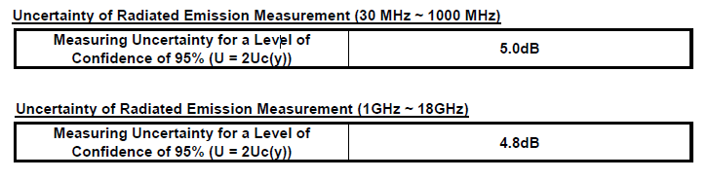

# GENERAL INFORMATION

## Test Equipments List

|  |  |  |  |
| --- | --- | --- | --- |
| Description & Manufacturer | MODEL NO. | SERIAL NO. | Next Calibration date |
| WIDEBAND RADIO COMMUNICATION TESTER ROHDE & SCHWARZ | CMW500 | 148277 | 2019/10/16 |
| SIGNAL ANALYZER ROHDE & SCHWARZ | FSQ26 | 200393 | 2019/4/9 |
| CMU200 ROHDE & SCHWARZ | CMU200 | 117747 | 2018/5/30 |
| Temperature Chamber WEISS | Temperature Chamber | '58226087670060 | 2019/3/5 |
| DC Power Supply Agilent | E3632A | MY40029031 | 2019/3/5 |
| RF cable | Huber Suhner SUCOFLEX 104PE | - | - |
| PC | - | 30008979 | - |
| Power Divider | - | C279810-01 | - |
| Universal radio communication tester | CMU 200 | 100677 | 2019.4.9 |
| Antenna | ETS 3142C | 79888 | 2019.1.29 |
| Antenna | ETS 3117 | 57412 | 2019.1.25 |
| EMI test receiver | ESU | 100041 | 2019.4.9 |
| EMC32 software | R&S | - | - |
| ETS 3M Semi-Anechoic Chamber | 9.47m*6.59m*5.91m | A88030002609000010071 | 2019.1.22 |

NOTE: Calibration cycle 12 months.

## Description of Test Modes

|  |  |  |
| --- | --- | --- |
| **Test items** | **function type** | **Channel** |
| Conducted Output Power | GSM850/PCS1900(GMSK+8PSK)+WCDMA BAND5(RMC 12.2kbps) | L/M/H |
| peak-to-average ratio | L/M/H |
| Bandwidth | L/M/H |
| Band Edges | L/H |
| Spurious Emission | L/M/H |
| Frequency Stability | M |
| Effective Radiated Power and Effective Isotropic Radiated Power | L/M/H |
| Filed Strength of Spurious Radiation | GSM 850 TX mode /PCS 1900 TX mode/ WCDMA Band5 TX mode | M |

## Test Environment and List of Software and Accessory

|  |  |  |  |
| --- | --- | --- | --- |
| **Test Items** | **Software** | **Accessory** | **Environment** |
| Conducted Output Power | - | USB Cable、Fake battery、Power Divider | Temp.:25℃±3 |
| Humi:30%~60% |
| Volt.:3.8V |
| peak-to-average ratio | - | USB Cable、Fake battery、Power Divider | Temp.:25℃±3 |
| Humi:30%~60% |
| Volt.:3.8V |
| Bandwidth | - | USB Cable、Fake battery、Power Divider | Temp.:25℃±3 |
| Humi:30%~60% |
| Volt.:3.8V |
| Band Edges | - | USB Cable、Fake battery、Power Divider | Temp.:25℃±3 |
| Humi:30%~60% |
| Volt.:3.8V |
| Spurious Emission | - | USB Cable、Fake battery、Power Divider | Temp.:25℃±3 |
| Humi:30%~60% |
| Volt.:3.8V |
| Frequency Stability | - | USB Cable、Fake battery、Power Divider | Temp.:-20℃~60℃ |
| Humi:30%~60% |
| Volt.:3.8、3.42、4.18V |
| Effective Radiated Power and Effective Isotropic Radiated Power | - | USB Cable、Fake battery、Power Divider | Temp.:25℃±3 |
| Humi:30%~60% |
| Volt.:3.8V |
| Filed Strength of Spurious Radiation | EMC32 | Charger: AC-10UC(NOKIA) Headset: HSEJ03JY(Mi) | Temp.:25℃±3 |
| Humi:30%~60% |
| Volt.:3.8V |

## Testing Location

|  |  |
| --- | --- |
| **Test Site** | BYD Precise Manufacture Co., Ltd. |
| **Test Site Location** | No. 3001, Baohe Road, Baolong Longgang, Shenzhen, 518116, People’s Republic of China |
| **Post Code** | 518116 |
| **Telephone** | +86-755 8489 8888 55501 |
| **Fax** | +86-755 8964 3771 |

## Test Facility

The test facility is recognized, certified, or accredited by the following organizations:

**• A2LA (Certificate No. 4886.01)**

BYD Precise Manufacture Co., Ltd., Baolong Shenzhen Laboratory is accredited by the American Association for Laboratory Accreditation (A2LA). Certificate No. 4886.01.

**• FCC –Designation Number: CN1232**

BYD Precise Manufacture Co., Ltd., Baolong Shenzhen Laboratory has been recognized as an accredited testing laboratory.

Designation Number: CN1232.

## Configuration of System Under Test

Conducted:

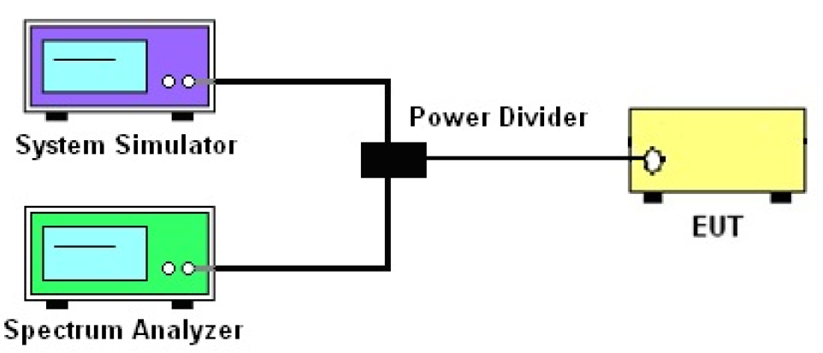

Radiated:

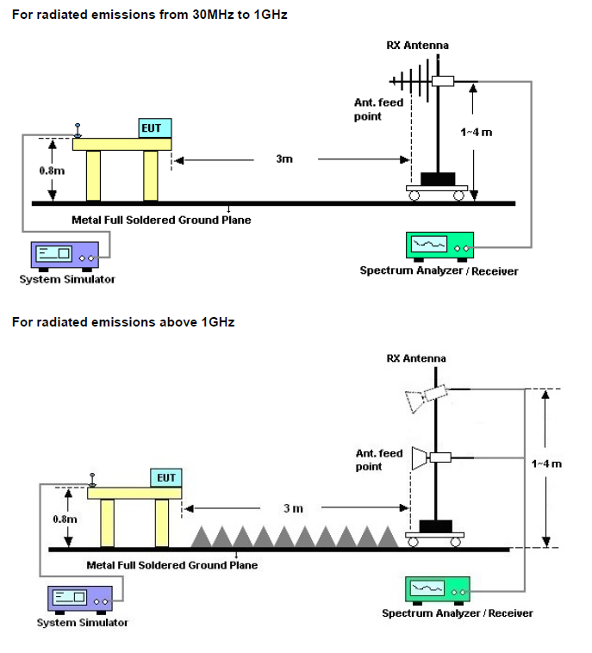

## General Description of Applied Standards

The EUT is a RF Product. According to the specifications of the manufacturer, it must comply with the requirements of the following standards:

FCC 47 CFR Part2, 22(H), 24(E), 27(L)

ANSI/TIA/EIA-603-D-2010

FCC KDB 971168 D01 Power Meas. License Digital Systems v02r02

All test items have been performed and recorded as per the above standards.

# TEST TYPES AND RESULTS

## Conducted Output Power (Reporting Only)

### Description of the Conducted Output Power

A system simulator was used to establish communication with the EUT. Its parameters were set to enforce EUT transmitting at the maximum power. The measured power in the radio frequency on the transmitter output terminals shall be reported

### Test Instruments

The measuring equipment is listed in the section 4.1 of this test report.

### Test Procedure

1. The transmitter output port was connected to the system simulator.
2. Set EUT at maximum power through system simulator.
3. Select lowest, middle, and highest channels for each band and different modulation.
4. Measure the maximum burst average power for GSM and maximum average power for other modulation signal.

### Test Setup



### Test Result

Conducted Output Power (Average power) – Result

## Peak-To-Average Ratio

### Description

The peak-to-average ratio (PAR) of the transmission may not exceed 13dB.

### Test Instruments

The measuring equipment is listed in the section 4.1 of this test report.

### Test Procedure

1. The EUT was connected to the spectrum analyzer and system simulator via a power divider.
2. Set EUT in maximum power output.
3. For GSM, Set spectrum analyzer: RBW=1MHz, VBW=3MHz, Peak detector on spectrum analyzer for first trace, RMS detector on spectrum analyzer for second trace. Record the deviation as Peak to Average Ratio.
4. For WCDMA, Set the CCDF (Complementary Cumulative Distribution Function) option of the spectrum analyzer. Record the maximum PAPR level associated with a probability of 0.1%.

### Test Setup

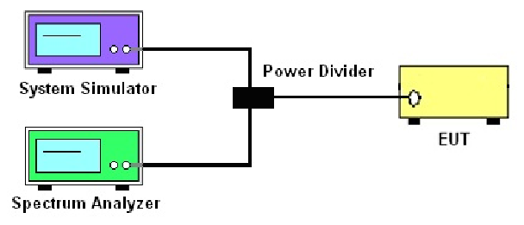

### Test Result

Peak-to-Average Ratio – Result

Peak-to-Average Ratio – Photograph

## 99% & 26dB Occupied Bandwidth (Reporting Only)

### Description of 99% Occupied Bandwidth and 26 dB Bandwidth Measurement

The 99% occupied band width is the width of a frequency band such that, below the lower and above the upper frequency limits, the mean powers emitted are each equal to a specified percentage 0.5% of the total mean transmitted power.

The emission bandwidth is defined as the frequency range between two points, one above and one below the carrier frequency, at which the spectral density of emission is attenuated 26 dB below the maximum in-band spectral density of the modulated signal. Spectral density (power per unit bandwidth) is to be measured with a detector of resolution bandwidth equal to approximately 1.0% of the emission bandwidth.

### Test Instruments

The measuring equipment is listed in the section 4.1 of this test report.

### Test Procedure

1. The EUT was connected to the spectrum analyzer and system simulator via a power divider.
2. The spectrum analyzer center frequency is set to the nominal EUT channel center frequency. The span range for the spectrum analyzer shall be between two and five times the anticipated OBW.
3. The 99% occupied bandwidth were measured, set RBW=1~5% of the anticipated OBW, VBW≥3*RBW, peak detector, trace maximum hold.
4. Determine the reference value: Set the EUT to transmit a modulated signal. Allow the trace to stabilize. Set the spectrum analyzer marker to the highest level of the displayed trace. (this is the reference value)
5. Use the 99% power bandwidth function of the spectrum analyzer and report the measured bandwidth.
6. Use the N dB Down function of the spectrum analyzer and report the measured bandwidth.

### Test Setup



### Test Result

26dB Bandwidth & Occupied Bandwidth – Result

26dB Bandwidth – Photograph

Occupied Bandwidth – Photograph

## Conducted Band Edge

### Description of Conducted Band Edge Measurement

The power of any emission outside of the authorized operating frequency ranges must be lower than the transmitter power (P) by a factor of at least 43 + 10log (P) dB.

### Test Instruments

The measuring equipment is listed in the section 4.1 of this test report.

### Test Procedure

1. The EUT was connected to the spectrum analyzer and system simulator via a power divider.
2. The RF output of the EUT was connected to the spectrum analyzer by RF cable and attenuator. The path loss was compensated to the results for each measurement.
3. The band edges of low and high channels for the highest RF powers were measured.
4. The RF fundamental frequency should be excluded against the limit line in the operating frequency band.
5. The limit line is derived from 43+ 10log (P) dB below the transmitter power P (Watts).

= P(W)-[43 + 10log(P)](dB)

= [30 + 10log (P)] (dBm)-[43+10log (P)](dB)

= -13dBm.

### Test Setup



### Test Result

Conducted Band Edge – Result

Conducted Band Edge – Photograph

## Conducted Spurious Emissions

### Description of Conducted Spurious Emission Measurement

The power of any emission outside of the authorized operating frequency ranges must be lower than the transmitter power (P) by a factor of at least 43+10log (P) dB.

It is measured by means of a calibrated spectrum analyzer and scanned from 30 MHz up to a frequency including its 10th harmonic.

### Test Instruments

The measuring equipment is listed in the section 4.1 of this test report.

### Test Procedure

1. The EUT was connected to the spectrum analyzer and system simulator via a power divider.
2. The RF output of the EUT was connected to the spectrum analyzer by RF cable and attenuator. The path loss was compensated to the results for each measurement.
3. The middle channel for the highest RF power within the transmitting frequency was measured.
4. The conducted spurious emission for the whole frequency range was taken.
5. The RF fundamental frequency should be excluded against the limit line in the operating frequency band.
6. The limit line is derived from 43+10log (P) dB below the transmitter power P (Watts).

= P(W)-[43 + 10log(P)](dB)

= [30 + 10log (P)] (dBm)-[43+10log (P)](dB)

= -13dBm.

### Test Setup



### Test Result

Conducted Spurious Emission – Result

Conducted Spurious Emission – Photograph

## Frequency Stability

### Description of Frequency Stability Measurement

The frequency stability shall be measured by variation of ambient temperature and variation of primary supply voltage to ensure that the fundamental emission stays within the authorized frequency block. The frequency stability of the transmitter shall be maintained within ±0.00025%(±2.5ppm) of the center frequency.

### Test Instruments

The measuring equipment is listed in the section 4.1 of this test report.

### Test Procedure for Temperature Variation

1. The EUT was set up in the thermal chamber and connected with the system simulator.
2. With power OFF, the temperature was decreased to -20℃ and the EUT was stabilized before testing. Power was applied and the maximum change in frequency was recorded within one minute.
3. With power OFF, the temperature was raised in 10℃ steps up to 60℃. The EUT was stabilized at each step for at least half an hour. Power was applied and the maximum frequency change was recorded within one minute.

### Test Procedure for Voltage Variation

1. The EUT was placed in a temperature chamber at 25±5℃ and connected with the system simulator.
2. The power supply voltage to the EUT was varied from 3.42V to 4.18V measured at the input to the EUT.
3. The variation in frequency was measured for the worst case.

### Test Setup

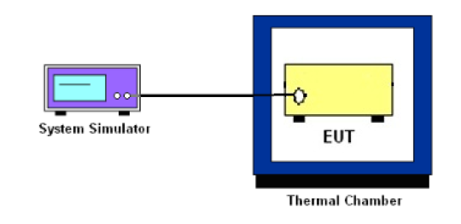

### Test Result

Test Result of Temperature Variation

|  |  |  |  |  |
| --- | --- | --- | --- | --- |
| Band: | GSM850 | | Channel: | 190 |
| Limit(ppm) | 2.5 | | Frequency: | 836.6MHZ |
| Temperature  (℃) | GSM  Deviation  (ppm) | GPRS  Deviation  (ppm) | EGPRS  Deviation  (ppm) | Result |
| -20 | +0.02 | +0.03 | +0.03 | PASS |
| -10 | +0.02 | +0.03 | +0.03 |
| 0 | +0.02 | +0.03 | +0.03 |
| 10 | +0.02 | +0.03 | +0.03 |
| 20(Ref.) | +0.02 | +0.03 | +0.03 |
| 30 | +0.02 | +0.03 | +0.03 |
| 40 | +0.02 | +0.02 | +0.04 |
| 50 | +0.02 | +0.03 | +0.03 |
| 60 | +0.02 | +0.03 | +0.03 |

|  |  |  |  |  |
| --- | --- | --- | --- | --- |
| Band: | PCS1900 | | Channel: | 661 |
| Limit(ppm) | 2.5 | | Frequency: | 1880.0MHZ |
| Temperature  (℃) | GSM  Deviation  (ppm) | GPRS  Deviation  (ppm) | EGPRS  Deviation  (ppm) | Result |
| -20 | +0.01 | +0.01 | +0.01 | PASS |
| -10 | +0.01 | +0.01 | +0.02 |
| 0 | +0.01 | +0.01 | +0.01 |
| 10 | +0.01 | +0.01 | +0.01 |
| 20(Ref.) | +0.01 | +0.01 | +0.01 |
| 30 | +0.02 | +0.02 | +0.01 |
| 40 | +0.00 | +0.01 | +0.01 |
| 50 | +0.01 | +0.01 | +0.02 |
| 60 | +0.01 | +0.01 | +0.01 |

|  |  |  |  |
| --- | --- | --- | --- |
| Band: | WCDMA BAND5 | Channel: | 4182 |
| Limit(ppm) | 2.5 | Frequency: | 836.4MHZ |
| Temperature(℃) | Deviation(ppm) | | Result |
| -20 | -0.0006 | | Pass |
| -10 | -0.0013 | | Pass |
| 0 | -0.0007 | | Pass |
| 10 | -0.0015 | | Pass |
| 20(Ref.) | -0.0004 | | Pass |
| 30 | -0.0003 | | Pass |
| 40 | -0.0005 | | Pass |
| 50 | -0.0002 | | Pass |
| 60 | -0.0002 | | Pass |

Test Result of Voltage Variation

|  |  |  |  |  |  |
| --- | --- | --- | --- | --- | --- |
| Band  Channel | Mode | Voltage | Deviation(ppm) | Limit(ppm) | Result |
| GSM 850  CH190 | GSM | LV | +0.02 | 2.5 | Pass |
| NV | +0.03 | 2.5 | Pass |
| HV | +0.02 | 2.5 | Pass |
| GPRS | LV | +0.02 | 2.5 | Pass |
| NV | +0.03 | 2.5 | Pass |
| HV | +0.02 | 2.5 | Pass |
| EGPRS | LV | +0.02 | 2.5 | Pass |
| NV | +0.03 | 2.5 | Pass |
| HV | +0.03 | 2.5 | Pass |
| PCS 1900  CH661 | GSM | LV | +0.01 | 2.5 | Pass |
|  | NV | +0.01 | 2.5 | Pass |
|  | HV | +0.01 | 2.5 | Pass |
| GPRS | LV | +0.01 | 2.5 | Pass |
| NV | +0.01 | 2.5 | Pass |
| HV | +0.01 | 2.5 | Pass |
| EGPRS | LV | +0.01 | 2.5 | Pass |
| NV | +0.01 | 2.5 | Pass |
| HV | +0.01 | 2.5 | Pass |
| WCDMA BAND5  CH4182 | RMC  12.2Kbps | LV | -0.0012 | 2.5 | Pass |
| NV | -0.0009 | 2.5 | Pass |
| HV | -0.0009 | 2.5 | Pass |

## Effective radiated power and effective isotropic radiated power measurement

### Description of the ERP/EIRP Measurement

The ERP of mobile transmitters must not exceed 7 Watts (Cellular Band) and the EIRP of mobile transmitters are limited to 2 Watts (PCS Band) and 1 Watts (AWS Band).

### Test Instruments

The measuring equipment is listed in the section 4.1 of this test report.

### Test Procedure

Effective Isotropic Radiated Power (EIPR) was calculated with the correction factor, EIPR=Conducted Output Power + Substitution antenna gain. ERP=EIRP-2.15.

### Test Result

EIPR / ERP Result

## Filed Strength of Spurious Radiation

### Description of Field Strength of Spurious Radiated Measurement

The power of any emission outside of the authorized operating frequency ranges must be attenuated below the transmitter power (P) by a factor of at least 43 + 10 log (P) dB. The spectrum is scanned from 30 MHz up to a frequency including its 10th harmonic.

### Test Instruments

The measuring equipment is listed in the section 4.1 of this test report.

### Test Procedures

1. The EUT was placed on a rotatable wooden table 0.8 meters above the ground.
2. The EUT was set 3 meters from the receiving antenna, which was mounted on the antenna tower.
3. The table was rotated 360 degrees to determine the position of the highest spurious emission.
4. The height of the receiving antenna is varied between one meter and four meters to search for the maximum spurious emission for both horizontal and vertical polarizations.
5. Make the measurement with the spectrum analyzer RBW = 1MHz, VBW = 3MHz, taking record of maximum spurious emission.
6. A horn antenna was substituted in place of the EUT and was driven by a signal generator.
7. Tune the output power of signal generator to the same emission level with EUT maximum spurious emission.
8. Taking the record of output power at antenna port.
9. Repeat step 7 to step 8 for another polarization.
10. EIRP (dBm) = S.G. Power – Tx Cable Loss + Tx Antenna Gain
11. ERP (dBm) =EIRP-2.15
12. The limit line is derived from 43 + 10log(P) dB below the transmitter power P(Watts)

=P(W) – [43 + 10log(P)](dB)

=[30 + 10log(P)](dBm) – [43 + 10log(P)](dB)

=-13dBm.

### Test Setup



### Test Result

# APPENDIX A. TEST SETUP PHOTOGRAPHS

# APPENDIX B. INFORMATION ON THE TESTING LABORATORIES

We, BYD Precise Manufacture Co., Ltd., were founded in 2007 to provide our best service in RF, Radio consultation. Our laboratories are accredited by the following accreditation bodies according to ISO/IEC 17025 (2005) .

|  |  |
| --- | --- |
| **USA** | A2LA  Certificate No.: 4886.01 |

Copies of accreditation certificates could be inquired from our office. If you have any comments, please feel free to contact us at the following:

|  |  |
| --- | --- |
| **EMC / RF / Lab**: Tel: +86-755 8489 8888 55501 Fax: +86-755 8964 3771 |  |
|  |  |
|  |  |
|  |  |
|  |  |

**--- END ---**